**Faculty of Computers and Artificial Intelligence**

**Cairo University**

Report For Graduation Project

Created For Professor **Mahmoud Eid** by Team Members:

* Mohamed Hisham Abdelzaher
* Yousef Mohamed Abd El-Hay
* Abdelrahman Mostafa Mohamed
* Beshoy Madhat Sadeq
* Rina Khaled Ahmed
* Shereen Ashraf Ahmed

GitHub: <https://github.com/MH0386/graduation_project>

Email: [alpha-AI@googlegroups.com](mailto:alpha-AI@googlegroups.com)

# Handwritten BCI Recognition

**Brain-computer interfaces** (BCIs) allow people with disabilities to communicate and control devices using their thoughts. Handwritten BCIs are easy to use and can be used by people with a wide range of disabilities. However, they can be slow and inaccurate and require electrodes to be worn on the head. Handwritten BCI Recognition is a BCI system that uses brain signals to recognize handwritten letters and symbols. It could revolutionize how people with disabilities interact with computers. The system is still in development, but it has the potential to make a real difference in people's lives.

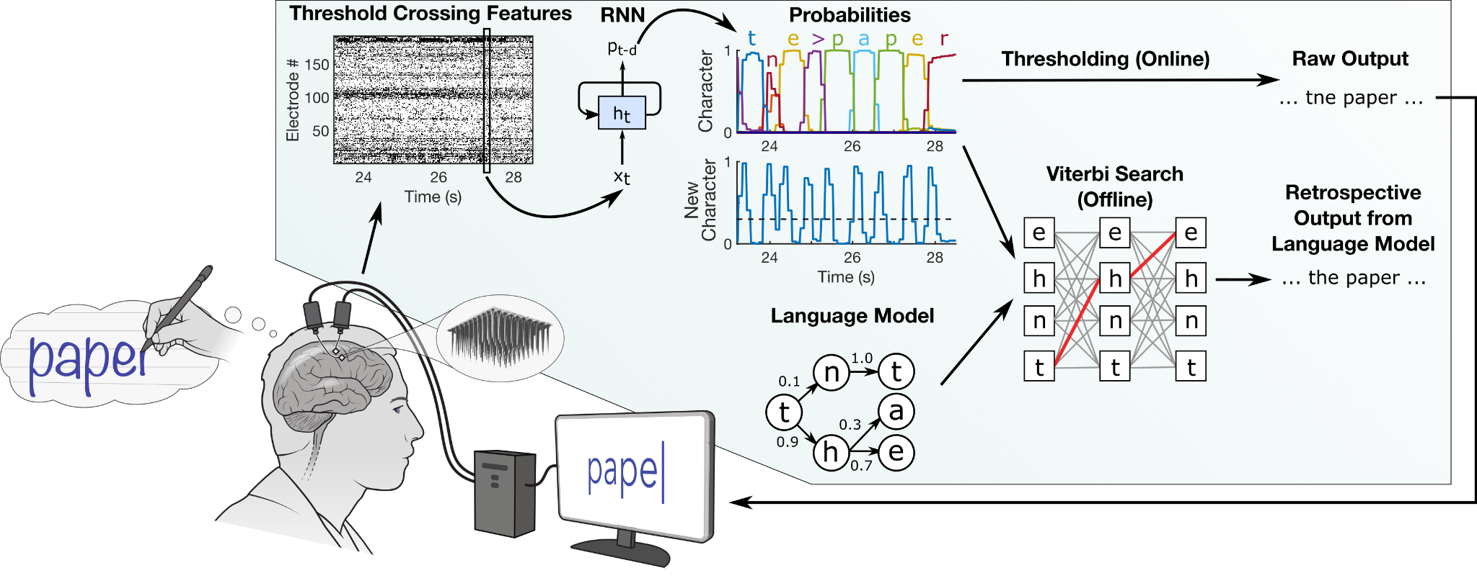

A great deal of research has been conducted on handwritten brain-computer interfaces (BCIs) in recent years. One of the most important challenges in this area is developing algorithms that can accurately decode handwriting from brain signals. Several different algorithms have been developed, but none of them are perfect. Another challenge is developing electrodes that are comfortable and easy to wear. Electrodes that are too tight can cause pain, while too loose electrodes can lead to poor signal quality. There are several approaches to recognizing handwriting using neural signals. One approach involves using non-invasive neural datasets, such as electroencephalography (EEG), to recognize handwritten characters. Another approach involves using invasive neural datasets, such as intracortical BCI, to decode imagined handwriting into real-time text. Machine learning methods are commonly used for training neural signals for handwriting recognition. These methods include classical classification methods and deep learning methods. Preprocessing techniques and feature extraction methods are also used to improve the accuracy of handwriting recognition. Finally, researchers are working on developing algorithms that can be used to control a variety of devices. This includes computers, wheelchairs, and prosthetic limbs.

Handwritten BCIs have the potential to be used in a variety of applications. One of the most prominent applications is for people with disabilities who have difficulty communicating or using their hands. Handwritten BCIs could allow these individuals to type text, control a computer, or even drive a wheelchair. Handwritten BCIs could also be used in educational settings. For example, they could be used to help students with dyslexia or dysgraphia improve their handwriting. Finally, handwritten BCIs could be used in entertainment settings. For instance, they could be used to control video games or create art. Machine learning methods and Neural signals are commonly used to recognize the efficient approach of using a CNN-based pre-trained model in Bangla handwritten digit recognition of handwritten characters, but there are still several challenges to overcome. Handwritten recognition systems have several potential applications, including restoring communication and translating handwriting into different languages. Overall, the field of handwritten recognition using BCI is rapidly growing and has the potential to improve the lives of individuals with disabilities. However, there are still some challenges that need to be addressed before this technology can be widely used. Some of the challenges that need to be addressed include:

* Developing more accurate and efficient algorithms for decoding handwriting from brain signals
* Developing more comfortable and easy-to-wear electrodes
* Developing algorithms that can be used to control a wider range of devices

The accuracy of Handwritten BCI Recognition models varies depending on the dataset used, the type of model, and the specific application. The accuracy of an EEG-based system, including one involving an "EXG pill," depends on several factors, such as the quality of the hardware, the signal processing techniques used, the training data, and the deep learning models employed. Achieving high accuracy in EEG-based applications, particularly for BCI projects, can be challenging due to the noise and variability inherent in brain signals. It's essential to carefully design and calibrate the system, preprocess the signals effectively, and employ appropriate machine learning or deep learning techniques to achieve the best possible accuracy. If you're working on a specific project involving an EXG pill for EEG analysis, it's important to thoroughly evaluate and validate the system's accuracy using relevant benchmarks and real-world data. The BioAmp EXG Pill is a small and powerful analog front-end (AFE) biopotential signal acquisition board that can be paired with any 5V microcontroller unit (MCU) with an analog-to-digital converter (ADC), such as Arduino UNO and Nano, Espressif ESP32, Adafruit QtPy, STM32 Blue Pill, BeagleBone Black, and Raspberry Pi Pico, to name just a few. It is capable of recording publication-quality biopotential signals like ECG, EMG, EOG, and EEG without the inclusion of any dedicated hardware or software filters. The BioAmp EXG Pill is sensitive to BioPotential signals, so it can even detect heartbeats by connecting the electrodes to your hands. The BioAmp EXG Pill project is open-source and has various Arduino example sketches and projects that are available for the BioAmp EXG Pill that you can use to create supportive technology.

## Reference

* [Handwriting BCI Dataset | Kaggle](https://www.kaggle.com/datasets/saurabhshahane/handwriting-bci)
* [An efficient approach to using a CNN-based pre-trained model in Bangla handwritten digit recognition](https://arxiv.org/abs/2209.13005)
* <https://www.kaggle.com/code/ajaysreeram/inference-test-gpu>
* <https://www.kaggle.com/code/zeta2191622/handbci-eda1-new>
* [https://besdatatech.com/eeg-electrodes](https://besdatatech.com/eeg-electrodes/?gad=1&gclid=Cj0KCQjwoK2mBhDzARIsADGbjeptvalHWky6oDdRNVf57Sc7o4eZVKY-xdIur-WaSNktP0xVlwAk-0kaAvBhEALw_wcB)
* [https://github.com/JGalego/eeg-bci-tutorial](https://github.com/JGalego/eeg-bci-tutorial/tree/master)
* [EEG analysis with MNE-Python and MNELAB](https://github.com/cbrnr/bci-event-2021)
* [MNE-Python Tutorial for EEG and MEG data analysis and visualization.](https://www.youtube.com/watch?v=sttf-Rgfl1Q)
* [DIY Neuroscience | Adafruit QtPy + BioAmp EXG Pill v1.0b | John Vivek | Measure ECG, EMG, EOG, EEG](https://www.youtube.com/watch?v=T6FRpDyJIEU)
* [BioAmp EXG Pill is a small and elegant Analog front-end (AFE) board for BioPotential signal acquisition.](https://github.com/upsidedownlabs/BioAmp-EXG-Pill)

# Glass with Computer Vision

AI-powered smart glasses use artificial intelligence to describe objects and read text aloud, helping the visually impaired. Some also have facial recognition, which can be used to identify people the wearer knows or to scan for information about them. This technology has the potential to revolutionize the lives of people with visual impairments, giving them a greater degree of independence and allowing them to participate more fully in society. AI-powered smart glasses are a type of wearable technology that uses artificial intelligence to help people with visual impairments. The glasses have a built-in camera that can scan the environment and identify objects, which are then spoken aloud to the wearer. This allows people with visual impairments to navigate their surroundings more easily and independently. Some smart glasses also have facial recognition capabilities, which can be used to identify people the wearer knows or to scan for information about them. This can be helpful for people with visual impairments who want to stay connected with friends and family or who need to access information quickly and easily. AI-powered smart glasses are still in their initial stages of development, but they have the potential to revolutionize the lives of people with visual impairments. By providing them with greater independence and access to information, these glasses can help people with visual impairments live more fulfilling and productive lives.

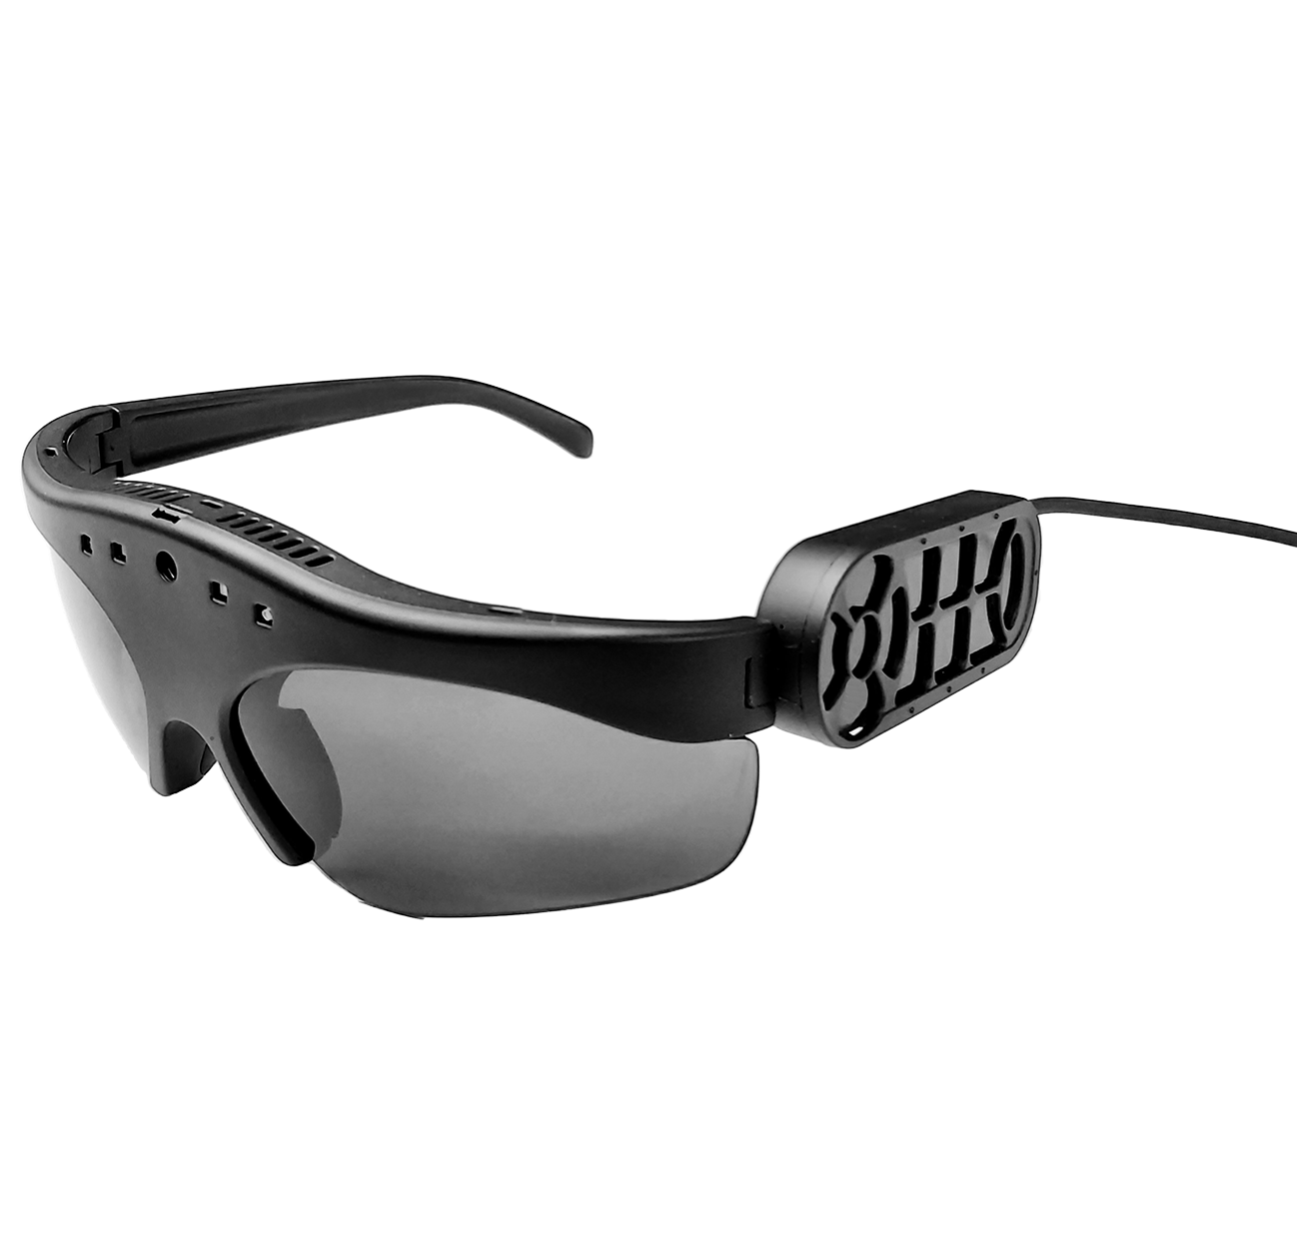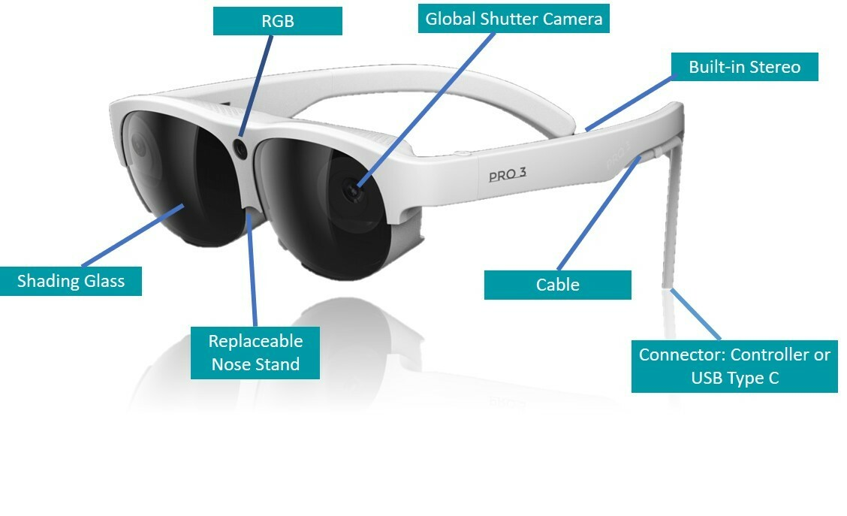

There are several AI-powered smart glasses available, such as:

* **Envision's smart glasses:** It is an AI-powered smart glass for people with visual impairments, including:
  + **Real-time text recognition:** The glasses can capture text in documents or on packaging and convert it into audio for the wearer to hear.
  + **Video calling:** Envision Glasses enables video calling, allowing users to connect with others visually.
  + **Scene description:** The glasses can describe the scene to the wearer, providing information about their surroundings.
  + **Object recognition:** Envision Glasses can recognize and identify objects, making it easier for users to interact with their environment.
  + **Light detection:** The glasses can detect changes in light levels, helping users navigate different lighting conditions.
  + **Currency recognition:** Envision Glasses can recognize and identify different currencies, assisting users in handling money.
  + **Color detection:** The glasses can detect and describe colors, providing color information to the wearer.
  + **Facial recognition:** Envision Glasses have facial recognition capabilities, allowing users to recognize and interact with people.
  + **Hands-free and unobtrusive experience:** The glasses provide a hands-free and unobtrusive way for users to access the visual world.
  + **Comfortable and lightweight design:** Envision Glasses are designed to be worn all day with a comfortable and lightweight profile.
* **Amal Glass:** It isa smart glass device designed for individuals with visual impairments. The following are some of its features:
  + **Artificial intelligence:** Amal Glass is based on artificial intelligence and uses machine learning to provide real-time audio cues to the wearer.
  + **Camera and sensors:** The glasses contain a camera and sensors that capture images and data from the environment.
  + **Mobile application:** Amal Glassworks provides a mobile application that connects to the glasses and provides additional functionality.
  + **Multilingual support:** The glasses support Arabic and English, with plans to add Spanish, French, and other languages in the future.
  + **Virtual assistant:** Amal Glass provides a virtual assistant that enables wearers to know more about their surrounding environment.
  + **Prayer times:** The glasses can announce prayer times for Muslims.
  + **Qibla's position:** The glasses can help Muslims find the direction of the Qibla.
  + **People recognition:** The glasses can recognize and identify people, making it easier for users to interact with others.
  + **Flashlight:** The glasses have a built-in flashlight that can be used in low-light conditions.
  + **Weather:** The glasses can provide real-time weather information.
  + **Address:** The glasses can provide address information.
  + **TV remote control:** The glasses can be used as a TV remote control.
  + **Barcode and QR code reader:** The glasses can read barcodes and QR codes.
  + **System language settings:** The glasses allow users to change the system language settings.
* **NuEyes Pro:** It is a smart glasses device designed for individuals with visual impairments. Some of its features include:
  + **Hands-free magnification:** NuEyes Pro provides hands-free magnification of up to 12x, making it easier for users to see objects and text.
  + **OCR:** The glasses have OCR (optical character recognition) capabilities, allowing them to recognize and read out printed text.
  + **Lightweight:** NuEyes Pro is lightweight and comfortable to wear.
  + **Focus settings:** The glasses have four focus settings, making it easier for users to adjust the magnification to their needs.
  + **Color modes:** NuEyes Pro has six color modes, allowing users to adjust the colors and contrast of what they are looking at.
  + **Live view in full color:** The glasses provide a live view in full color, making it easier for users to see their surroundings.
  + **Bar/QR code scanning:** NuEyes Pro can scan barcodes and QR codes.
  + **Voice commands:** The glasses can be operated using simple voice commands.
  + **Samsung Galaxy S phone:** NuEyes Pro comes with a Samsung Galaxy S phone and charger.
  + **Patented low-vision software:** The glasses come with patented low-vision software.
* **AIRA:** It is a service that helps blind and visually impaired individuals navigate their surroundings with the assistance of live sighted guides. The service utilizes smart glasses or a phone camera to provide real-time video streaming to trained Aira agents. Here are some features of Aira:
  + **Live video streaming:** Aira connects users with sighted guides who use the live video stream from the smart glasses or phone camera to assist them in real time.
  + **Smart glasses and MiFi unit:** When signing up with Aira, users receive a pair of smart glasses and a small MiFi unit, which acts as a personal hotspot. The smart glasses integrate a 120-degree wide-angle camera to provide a fuller picture of the user's surroundings.
  + **AT&T network:** Aira utilizes the AT&T network for connectivity.
  + **Instant access to information:** With Aira, users have instant access to information and assistance, allowing them to navigate their surroundings more effectively.
  + **Remote assistance:** Aira agents can provide guidance and assistance with tasks such as reading signs, identifying objects, navigating unfamiliar environments, and more.
  + **Accessibility features:** Aira's smart glasses and service are designed specifically for individuals who are blind or have low vision, providing them with greater independence and accessibility.

## Reference

* [Envision Adds ChatGPT AI Sight Assistance to Its Smart Glasses for the Blind](https://www.forbes.com/sites/gusalexiou/2023/04/30/envision-adds-chatgpt-ai-sight-assistance-to-its-smart-glasses-for-the-blind)
* [Envision Presents Next Generation AI-Powered Smart Glasses for the Blind and Visually Impaired at CSUN 2022 ‍‍](https://www.letsenvision.com/blog/envision-presents-next-generation-ai-powered-smart-glasses-for-the-blind-and-visually-impaired-at-csun-2022)
* [Envision Glasses: Home Edition - AI-powered smart glasses](https://shop.letsenvision.com/products/envision-glasses-home)
* [Summary of Technical Specifications and Features For - Amal Glass](https://amalglass.com/info/AmalGlassEN.pdf)
* [Smart glasses for the blind and visually impaired](https://amalglass.com/index-en.html)
* [Three cool smart glasses to help people who are blind or have sight loss | AbilityNet](https://abilitynet.org.uk/news-blogs/three-cool-smart-glasses-help-people-who-are-blind-or-have-sight-loss)
* [NuEyes Announces New Pro 3 Augmented Reality Smart Glass Solution](https://www.nueyes.com/nueyes-announces-new-pro-3-augmented-reality-smart-glass-solution)
* [Aira helps the blind and visually impaired conquer their surroundings and the world - Healthcare Weekly](https://healthcareweekly.com/aira-smart-glasses/)
* [Aira’s new smart glasses give blind users a guide through the visual world | TechCrunch](https://techcrunch.com/2018/03/27/airas-new-smart-glasses-give-blind-users-a-guide-through-the-visual-world/)
* [GitHub - jashan20/Vision-For-Blind](https://github.com/jashan20/Vision-For-Blind)
* [GitHub - 5nax/Envision-AI](https://github.com/5nax/Envision-AI)
* [GitHub - abhinavcoder/Envision_App: Envision-Visually Impaired Assistance App](https://github.com/abhinavcoder/Envision_App)
* <https://www.perplexity.ai/search/4f2114f0-ba73-4564-bfe0-926db5b54452?s=c>
* [GitHub - TeamOpenSmartGlasses/OpenSourceSmartGlasses](https://github.com/TeamOpenSmartGlasses/OpenSourceSmartGlasses)
* [GitHub - alaamaalouf/FollowAnything](https://github.com/alaamaalouf/FollowAnything)

# Chat with Characters from History

The concept of my AI project is to create a platform that allows users to interact with historical figures and gather information about individuals from the past and present. The objectives of my project are to create a conversational AI system, simulate historical figures' personalities, and provide accurate historical information. The AI technology I plan to use for this project is a large language model, such as GPT-3.

A large language model is a type of artificial intelligence that can generate text, translate languages, write various kinds of creative content, and answer your questions in an informative way. It is trained on a massive amount of text data, and it can learn to mimic the style and content of the text it is trained on. This makes it ideal for creating a conversational AI system that can simulate the personalities of historical figures. The AI system will be trained on a dataset of historical texts, including speeches, writings, and interviews. This will allow the system to learn the language and mannerisms of historical figures. The system will also be trained on a dataset of historical facts so that it can provide accurate information about historical events and figures.

The platform will be designed to be user-friendly and engaging. Users will be able to choose from a variety of historical figures to interact with. They will be able to ask the figures questions, and the figures will respond naturally and engagingly. The platform will also provide users with access to historical information so that they can learn more about the figures they are interacting with.

This AI-powered app has a wide range of applications. The app can be used for **educational** purposes, allowing users to gain new insights and perspectives on history and life. It can also be used for entertainment, allowing users to have personal interactions with historical figures of their choice. The conversations are tailored to the user's interests, making it an immersive and engaging experience. The app can also be used to break down complicated concepts into simple language, making it easier for users to understand. However, there have been concerns about the app's inclusion of controversial figures such as Adolf Hitler. Overall, the app has the potential to revolutionize education and provide a unique and enriching experience for users.

## Reference

* [AI Chatbots Now Let You Talk to Historical Figures Like Shakespeare and Andy Warhol](https://mymodernmet.com/ai-history-chatbots/)
* [HeyMind: AI app to chat with historical figures ❤️](https://vivevirtual.es/en/inteligencia-artificial/heymind-aplicacion-ia-para-chatear-con-personajes-historicos/)
* [Hello History: AI-Powered Conversations with Influential Historical Figures](https://aidude.info/services/Hello-History)
* [Have A Chat With Hundreds Of Historical Figures: An Exciting New Way To Learn!](https://theeducationdaily.com/hundreds-of-historical-figures/)
* [Hello History](https://www.hellohistory.ai/)
* [OpenAssistant/oasst-sft-6-llama-30b-xor · Hugging Face](https://huggingface.co/OpenAssistant/oasst-sft-6-llama-30b-xor)
* [meta-llama/Llama-2-70b-chat-hf · Hugging Face](https://huggingface.co/meta-llama/Llama-2-70b-chat-hf)

# Frame Rate Enhancer

AI can enhance video frame rates by generating new frames between existing ones. This is done using deep learning algorithms such as video frame interpolation (VFI) and video super-resolution (VSR). Recent studies have proposed efficient methods for this, such as a one-stage space-time video super-resolution framework that can reconstruct high-resolution slow-motion video from low-resolution and low-frame-rate video. While the quality of interpolation is often reduced due to large object motion or occlusion, recent studies have proposed methods to address this, such as a video frame interpolation method that explicitly detects occlusion by exploring depth information. The accuracy of AI-based video frame interpolation models depends on several factors, but here is a list of popular and effective models. However, here is a list of the models based on their popularity and general effectiveness:

* [DVF](https://paperswithcode.com/paper/video-frame-synthesis-using-deep-voxel-flow) (**D**eep **V**oxel **F**low)
* [DAIN](https://paperswithcode.com/paper/depth-aware-video-frame-interpolation) (**D**epth-**A**ware Video Frame **In**terpolation)
* [RIFE](https://paperswithcode.com/paper/rife-real-time-intermediate-flow-estimation) (**R**eal-Time **I**ntermediate **F**low **E**stimation)
* [Super](https://github.com/avinashpaliwal/Super-SloMo) SloMo
* [RAFT](https://github.com/princeton-vl/RAFT) (**R**ecurrent **A**ll-Pairs **F**ield **T**ransforms)
* [TecoGAN](https://github.com/thunil/TecoGAN) (**Te**mporally **Co**herent **GAN**)
* [EDVR](https://paperswithcode.com/paper/edvr-video-restoration-with-enhanced) (**E**nhanced **D**eep **V**ideo **R**estoration)
* CAIN (**C**ontent-**A**ware **I**npainting **N**etwork)
* [MEMC-Net](https://paperswithcode.com/paper/memc-net-motion-estimation-and-motion-1) (**M**otion **E**stimation and **M**otion **C**ompensation **Net**work)
* [SepConv](https://paperswithcode.com/method/depthwise-separable-convolution) (**Sep**arable **Conv**olutional Networks)
* [Softmax](https://github.com/sniklaus/softmax-splatting) Splatting (**SS**)
* [TOFlow](https://paperswithcode.com/paper/video-enhancement-with-task-oriented-flow/review/) (**T**ask-**O**riented **Flow**)

In summary, video frame rate enhancement by artificial intelligence is a promising technique that can generate new frames in between existing frames of a video, resulting in a higher frame rate and smoother motion. There are several approaches to video frame rate enhancement using AI, including video frame interpolation (VFI) and video super-resolution (VSR). These approaches use deep learning algorithms to improve the quality of video frames and can be applied to various applications, such as face detection and recognition and image and video quality enhancement.

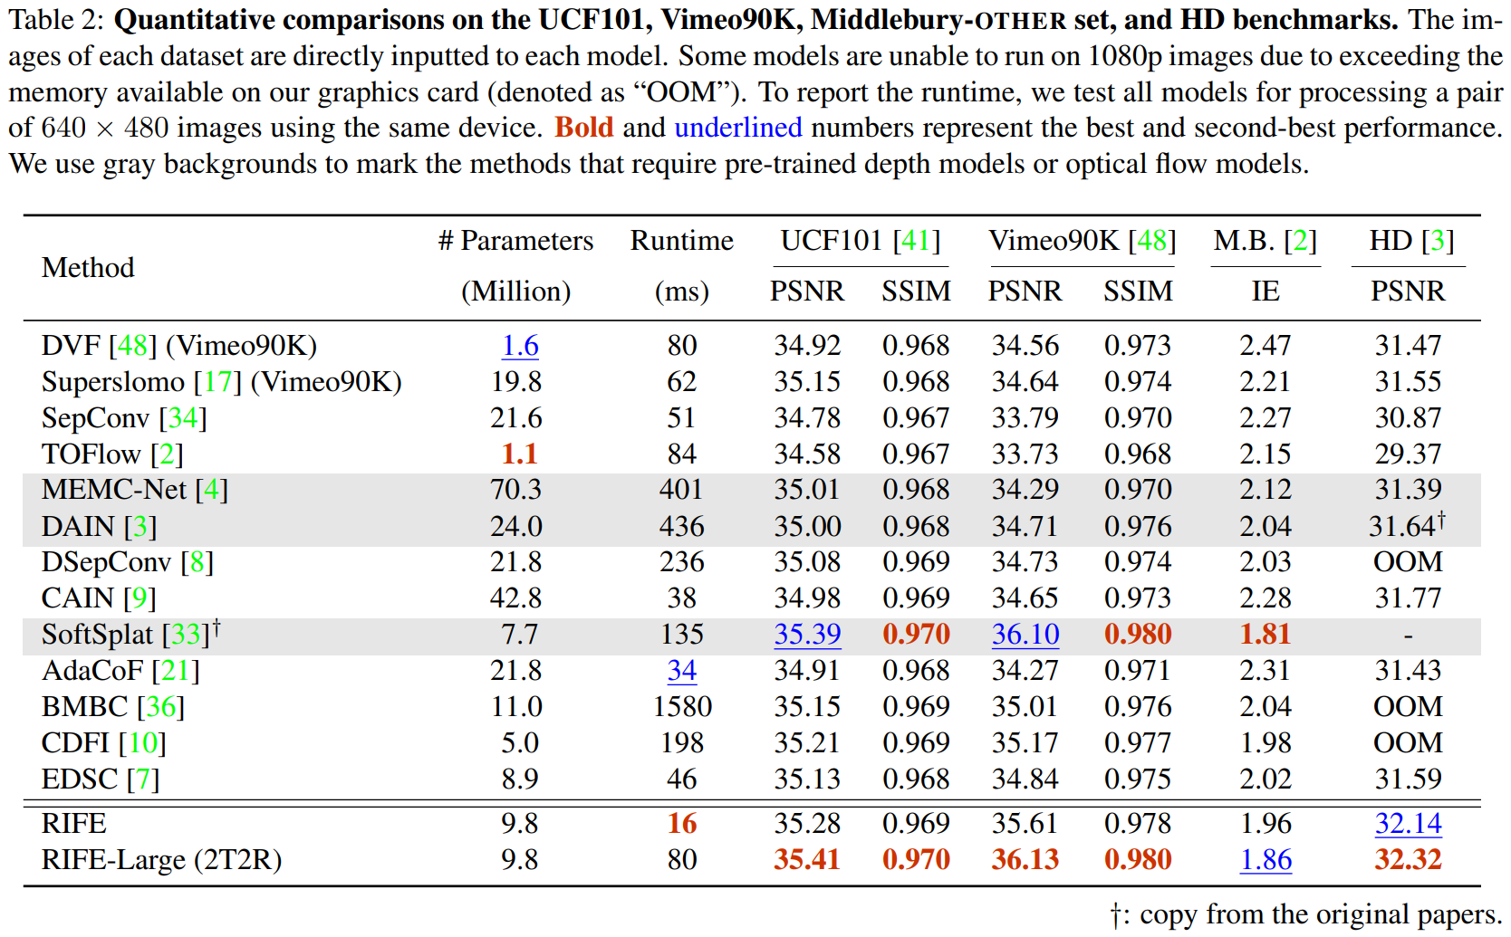

As we can see, RIFE is relatively better than others. It has an excellent **P**eak **signal-to-noise ratio** (PSNR) and **S**tructural **S**imilarity **I**ndex **M**easure (SSIM).

RIFE (Real-Time Intermediate Flow Estimation) is a video frame interpolation algorithm that uses a neural network to directly estimate intermediate flows from coarse to fine. This allows it to achieve much faster speeds than other methods. RIFE is a real-time algorithm that can process 720p videos at 30 frames per second. Additionally, RIFE is designed to directly estimate intermediate flows from coarse to fine, which can lead to better accuracy compared to other methods that first estimate bi-directional optical flows and then linearly combine them to approximate intermediate flows. According to the search results, RIFE is 4–27 times faster than the popular SuperSlomo and DAIN methods while producing better results. Additionally, RIFE is the first flow-based and real-time VFI algorithm that processes 720p videos at 30 frames per second. Therefore, RIFE is a faster and more efficient VFI algorithm than other methods.

In conclusion, RIFE is a fast and accurate video frame interpolation algorithm that is suitable for real-time applications.

## Reference

* [RIFE Explained | Papers With Code](https://paperswithcode.com/method/rife)
* [RIFE AI interpolation - SmoothVideo Project (SVP)](https://www.svp-team.com/wiki/RIFE_AI_interpolation)
* [GitHub: megvii-research/ECCV2022-RIFE: ECCV2022 - Real-Time Intermediate Flow Estimation for Video Frame Interpolation](https://github.com/megvii-research/ECCV2022-RIFE)
* [RIFE, Real-Time Intermediate Flow Estimation for Video Frame Interpolation](https://www.linkedin.com/pulse/rife-real-time-intermediate-flow-estimation-video-frame-westveer)
* [Real-Time Intermediate Flow Estimation for Video Frame Interpolation](https://arxiv.org/abs/2011.06294)
* [RIFE: Real-Time Intermediate Flow Estimation for Video Frame Interpolation | Papers With Code](https://paperswithcode.com/paper/rife-real-time-intermediate-flow-estimation)
* <https://www.arxiv-vanity.com/papers/2011.06294>
* [RIFE AI interpolation - SmoothVideo Project (SVP)](https://www.svp-team.com/wiki/RIFE_AI_interpolation)
* <https://arxiv.org/pdf/2105.13482.pdf>
* [Video Frame Interpolation | Papers With Code](https://paperswithcode.com/task/video-frame-interpolation)
* [Depth-Aware Video Frame Interpolation](https://arxiv.org/abs/1904.00830)
* [Transform Network Architectures for DL based End-to-End Image/Video Coding in Subsampled Color Spaces](https://arxiv.org/abs/2103.01760)
* https://pubmed.ncbi.nlm.nih.gov/32225742
* [IFRNet: Intermediate Feature Refine Network for Efficient Frame Interpolation](https://arxiv.org/abs/2205.14620)
* https://pubmed.ncbi.nlm.nih.gov/34346905
* [XVFI: eXtreme Video Frame Interpolation](https://arxiv.org/abs/2103.16206)
* [FILM: Frame Interpolation for Large Motion](https://arxiv.org/abs/2202.04901)
* [Asymmetric Bilateral Motion Estimation for Video Frame Interpolation](https://arxiv.org/abs/2108.06815)
* <https://www.ncbi.nlm.nih.gov/pmc/articles/PMC9163436>
* [SuperFast: 200× Video Frame Interpolation via Event Camera](https://pubmed.ncbi.nlm.nih.gov/36417747)
* [Time Lens++: Event-based Frame Interpolation with Parametric Non-linear Flow and Multi-scale Fusion](https://arxiv.org/abs/2203.17191)
* [Multiple Video Frame Interpolation via Enhanced Deformable Separable Convolution](https://arxiv.org/abs/2006.08070)
* [TimeLens: Event-based Video Frame Interpolation](https://arxiv.org/abs/2106.07286)
* [Enhanced Motion-Compensated Video Coding With Deep Virtual Reference Frame Generation](https://pubmed.ncbi.nlm.nih.gov/31059444)
* <https://www.ncbi.nlm.nih.gov/pmc/articles/PMC9480984>
* [Deep Learning for Content-based Personalized Viewport Prediction of 360-Degree VR Videos](https://arxiv.org/abs/2003.00429)
* [Many-to-many Splatting for Efficient Video Frame Interpolation](https://arxiv.org/abs/2204.03513)
* [PointINet: Point Cloud Frame Interpolation Network](https://arxiv.org/abs/2012.10066)
* [Learning Spatio-Temporal Downsampling for Effective Video Upscaling](https://arxiv.org/abs/2203.08140)
* [Unifying Motion Deblurring and Frame Interpolation with Events](https://arxiv.org/abs/2203.12178)
* [Power Efficient Video Super-Resolution on Mobile NPUs with DL, Mobile AI & AIM 2022 challenge](https://arxiv.org/abs/2211.05256)
* [ML Enhances Algorithms for Quantifying Non-Equilibrium Dynamics in Correlation Spectroscopy Experiments to Reach Frame-Rate-Limited Time Resolution](https://arxiv.org/abs/2201.07889)
* [Blurry Video Frame Interpolation](https://arxiv.org/abs/2002.12259)
* [Softmax Splatting for Video Frame Interpolation](https://arxiv.org/abs/2003.05534)
* [Inter-slice image augmentation based on frame interpolation for boosting medical image segmentation accuracy](https://arxiv.org/abs/2001.11698)
* [Artificial Intelligence-based Video Codec (AIVC) for CLIC 2022](https://arxiv.org/abs/2206.13934)
* [Wyner-Ziv video coding with classified correlation noise estimation and keyframe coding mode selection](https://pubmed.ncbi.nlm.nih.gov/21382768/)
* [FISR: Deep Joint Frame Interpolation and Super-Resolution with a Multi-scale Temporal Loss](https://arxiv.org/abs/1912.07213)
* <https://www.youtube.com/watch?v=Dgo7F-lpyYE>
* **Adobe240-FPS**: A dataset released by Adobe Systems that has high-frame-rate videos for training and evaluation
* **Middlebury**: The Middlebury dataset is a popular benchmark in computer vision, including video frame interpolation tasks. It provides a variety of high-quality video sequences with ground-truth frames.
* **Vimeo-90K**: A large-scale video dataset created by Vimeo with approximately 90,000 video clips with diverse content
* [**UCF101**](https://www.kaggle.com/datasets/pevogam/ucf101): The UCF101 dataset originally consisted of 101 action categories, but it can also be used for video frame interpolation tasks. It has a wide range of videos from various sources.